Step3: In the SVN Repositories view, select “New repository”. The Create SVN Repository dialog appears.

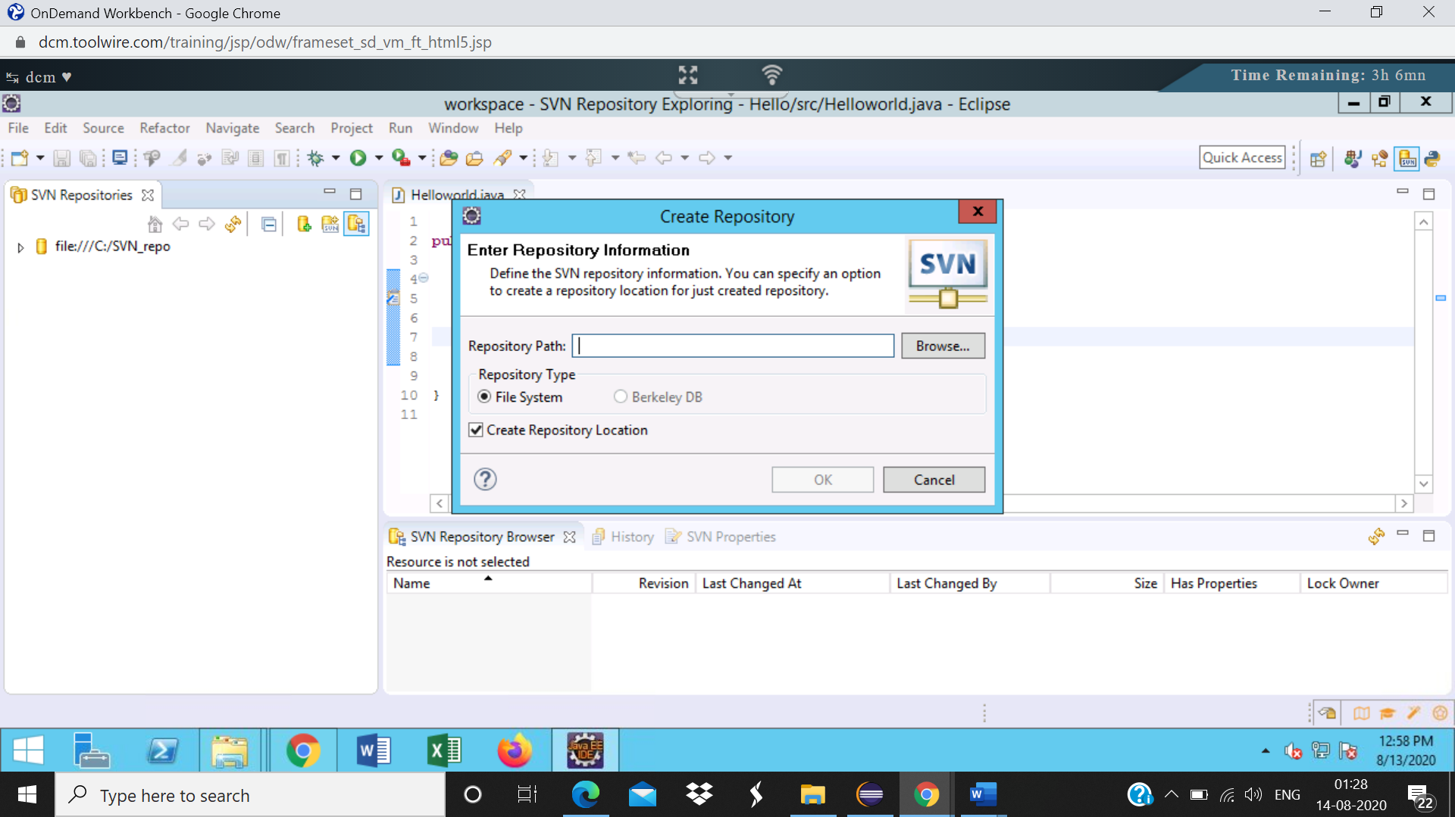

Step4: In the “Create SVN repository “ dialog box , click on browse -> select the repository you created and click ok.

New repo <file://C:SVN_repo1> is created

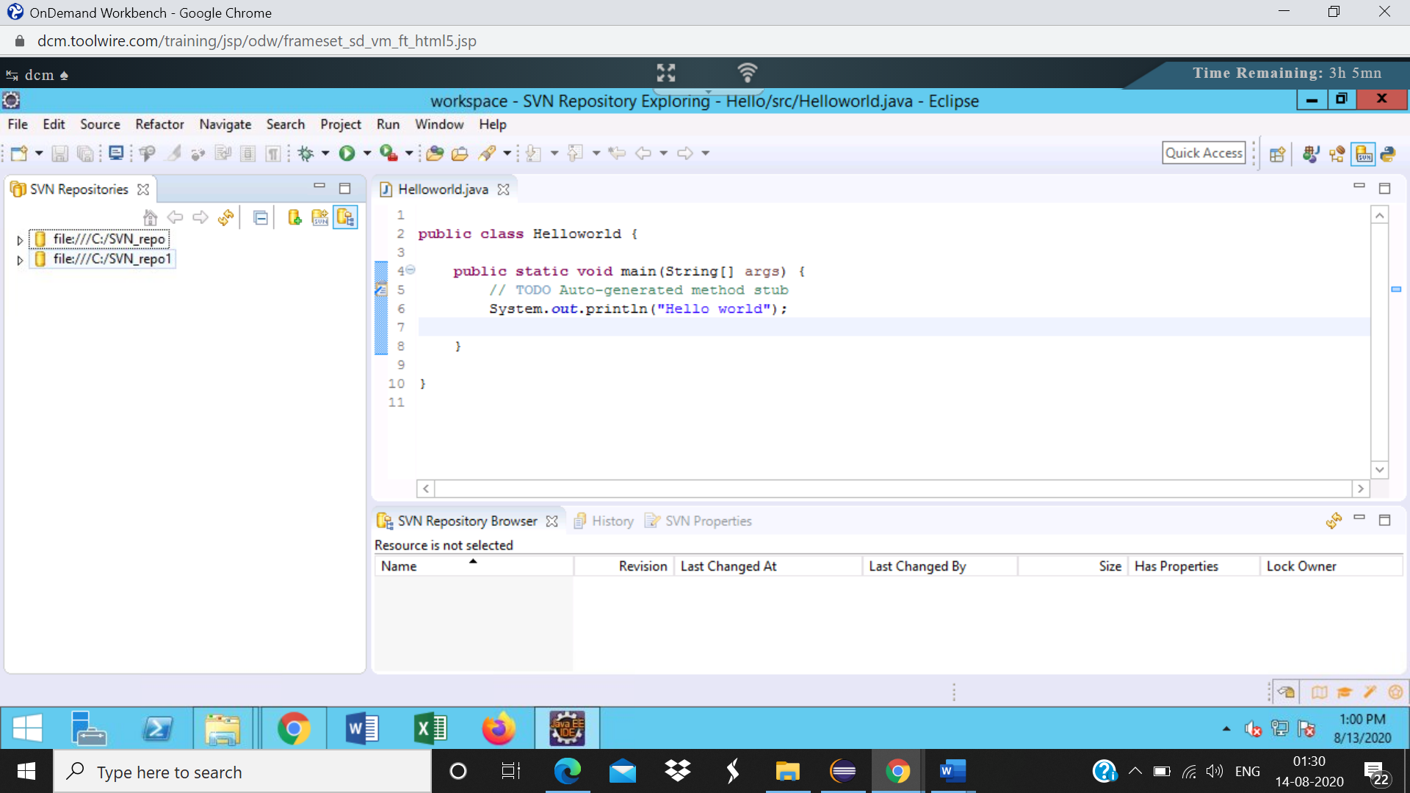

Step5: Open the explorer and navigate to the created repository. It should contain the following folders and files created automatically:  
a. conf  
b. db  
c. hooks  
d. locks  
e. format  
f. README

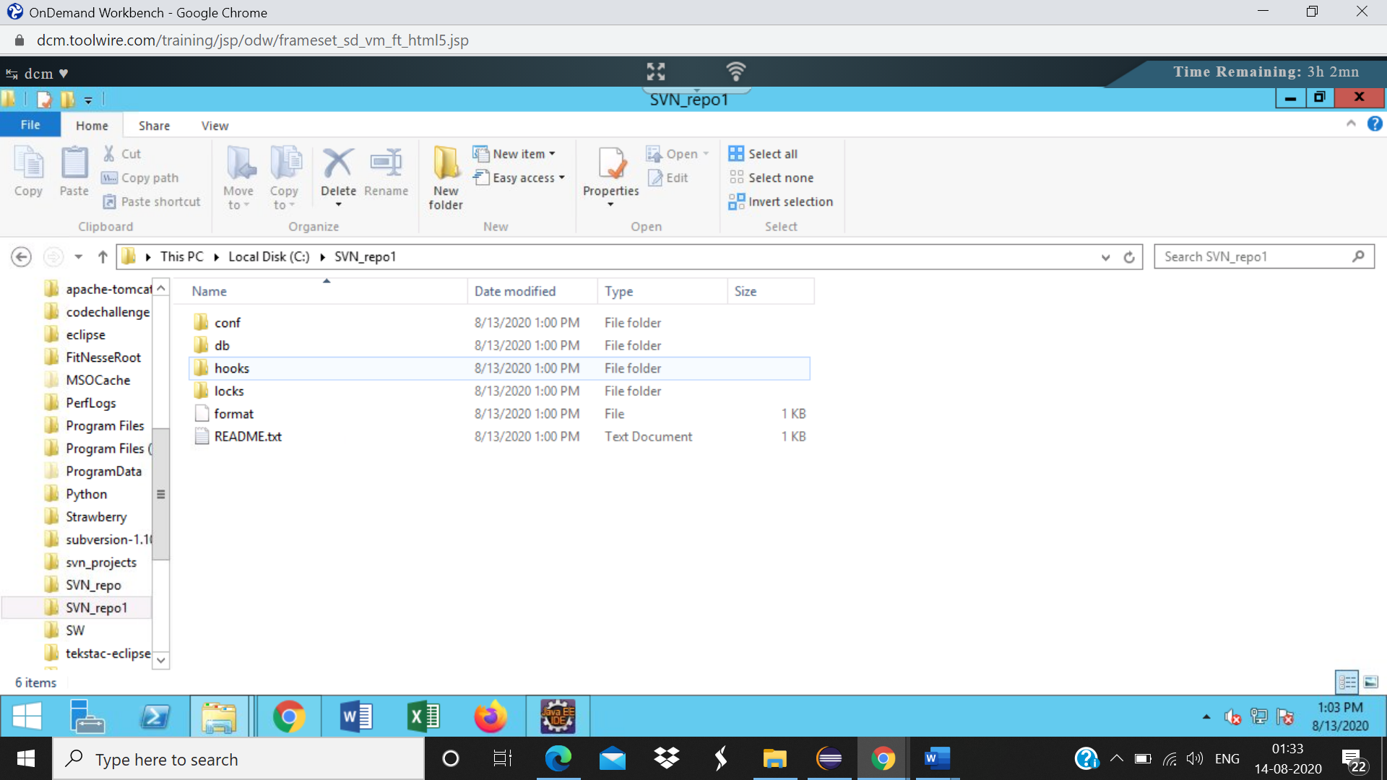

Step6: In eclipse, right click on the newly created repository and select “New”->”New folder”

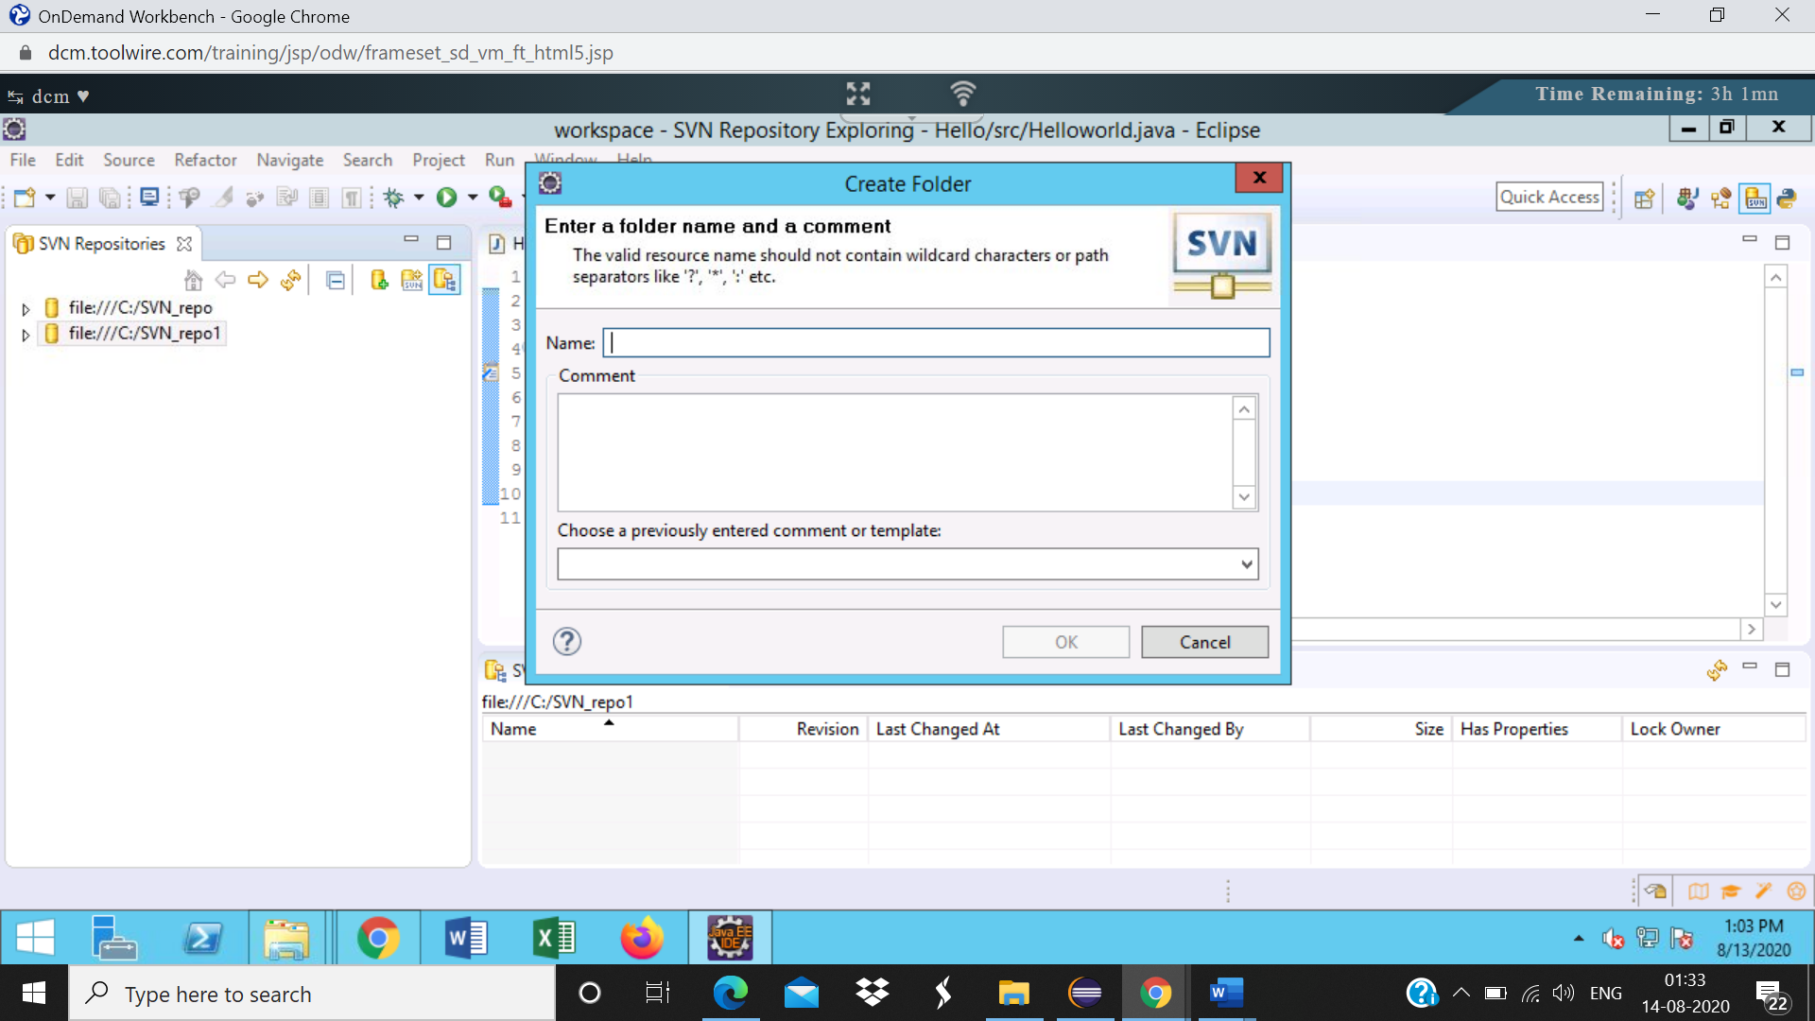

Step7:

|  |  |
| --- | --- |
| In the New remote folder dialog, enter the folder name as trunk and click on Next. Enter the commit message in the next screen and click on finish |  |

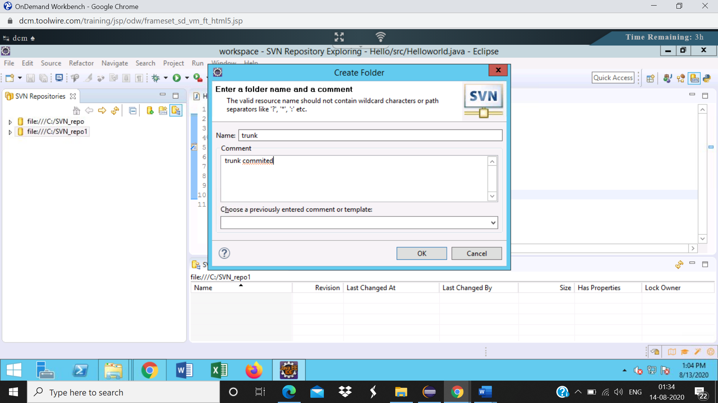

Trunk is present

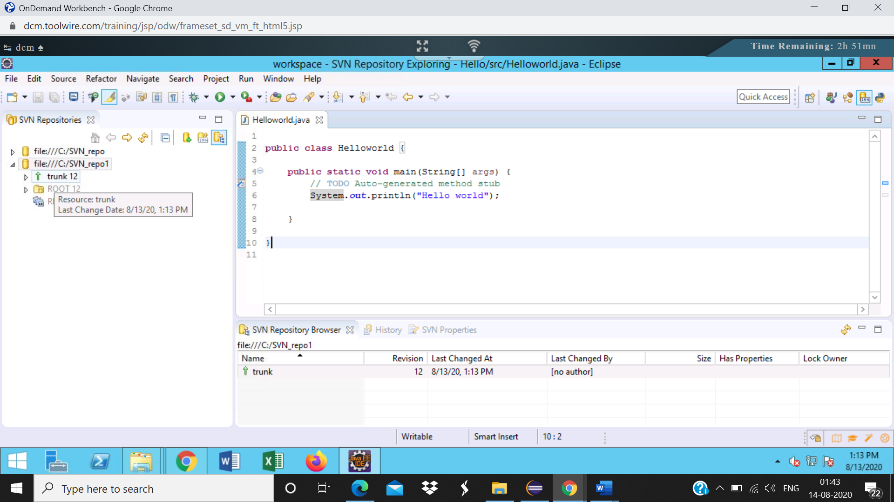

Step8: Create the tag and branch directories similarly

Tag created-

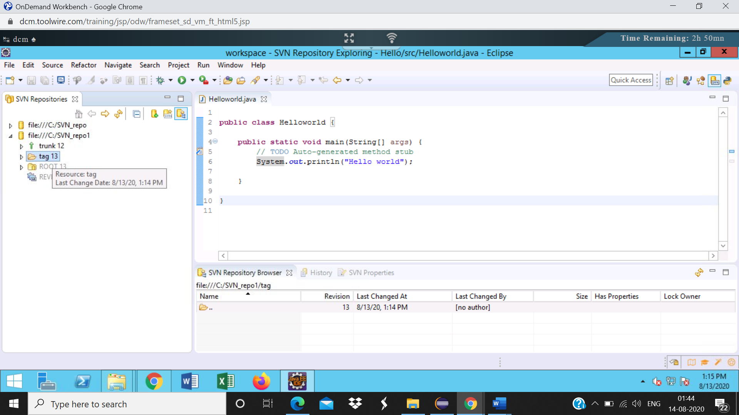

Branch created

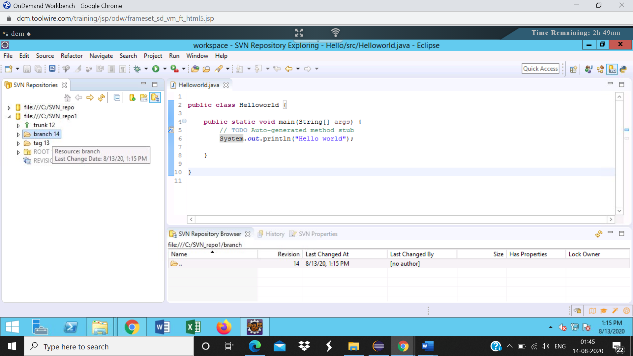Step10: In the import directory, browse and select**C:\svn_projects\project7**, enter the comments and click ok.Refresh the trunk.The project is added to the trunk

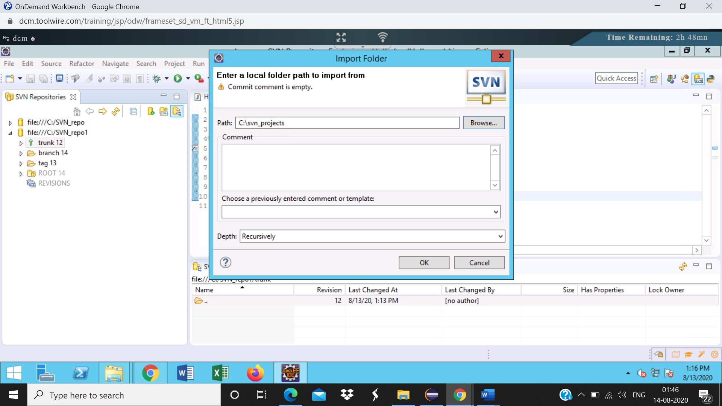

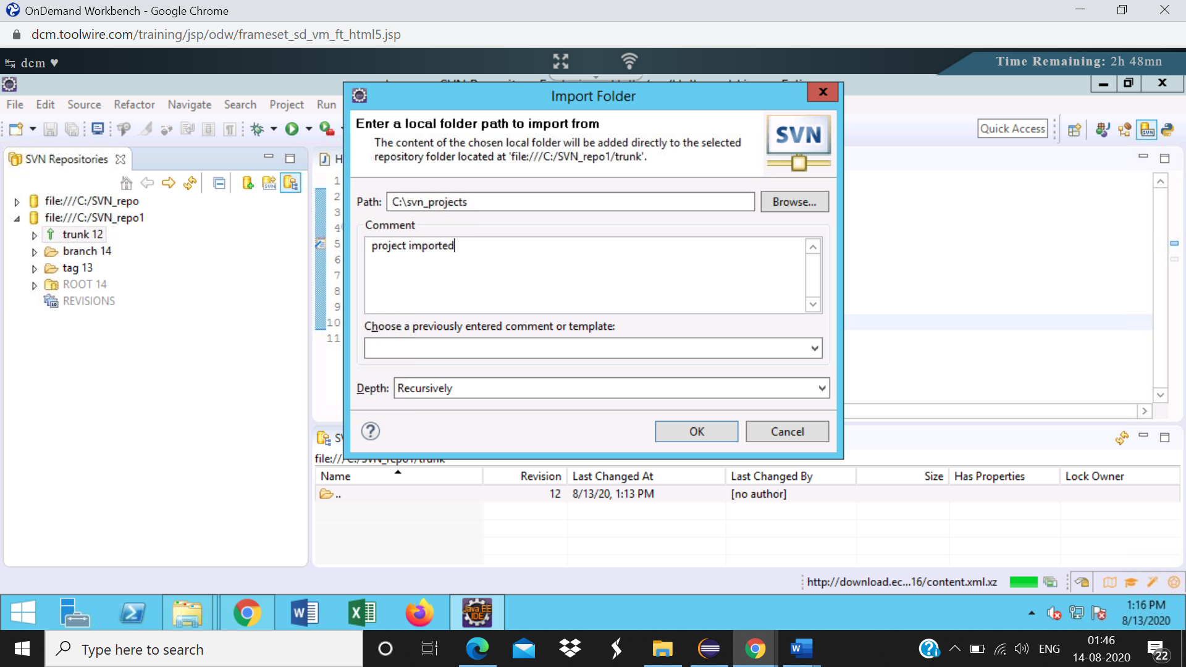

Project imported

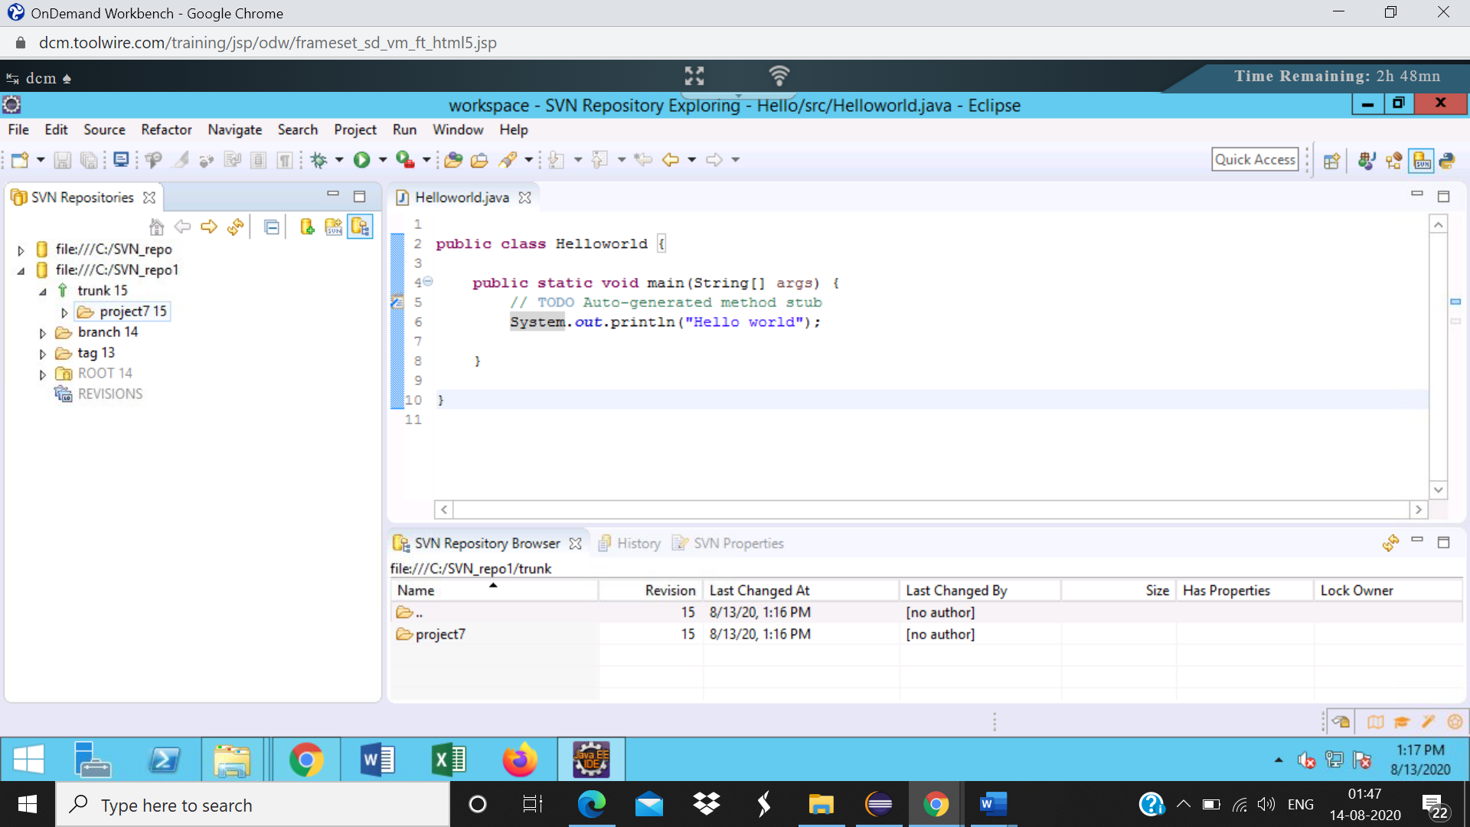Step11 :Now checkout the project into the workspace.  
Right click on project and select checkout

Project explorer screenshot

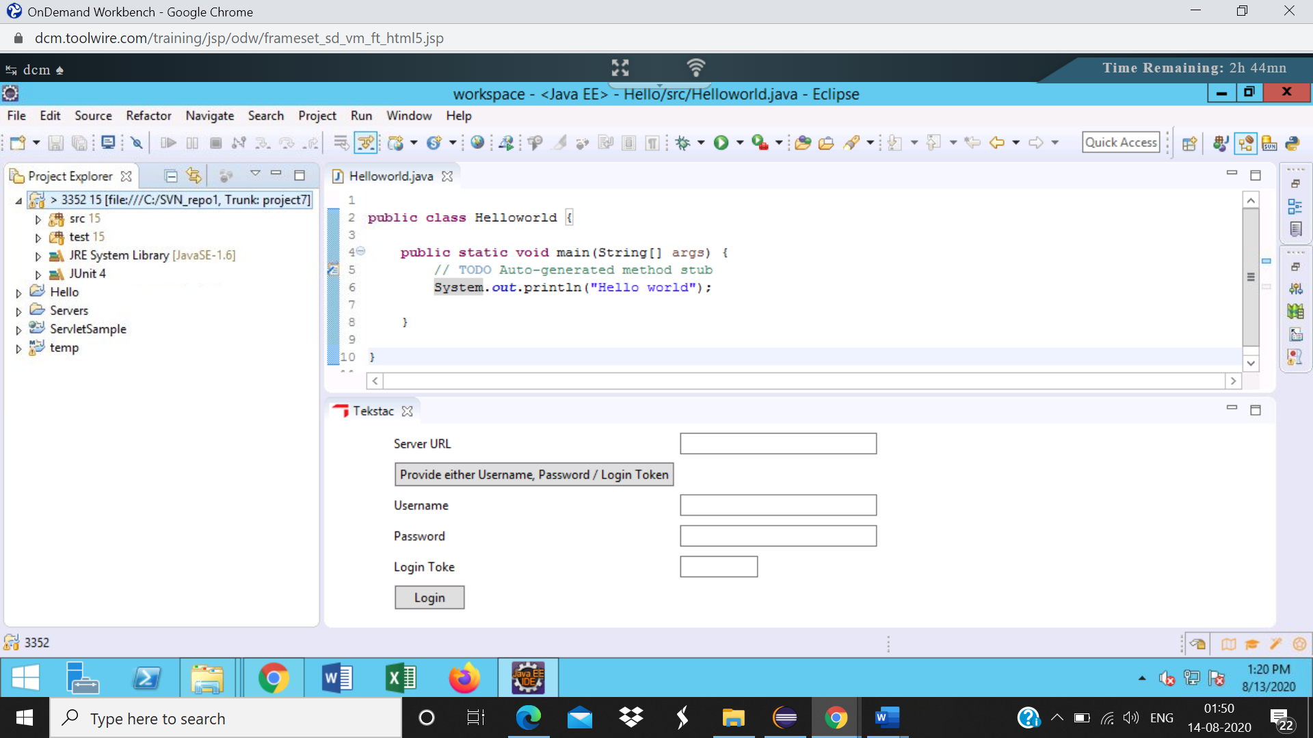

Step 11:

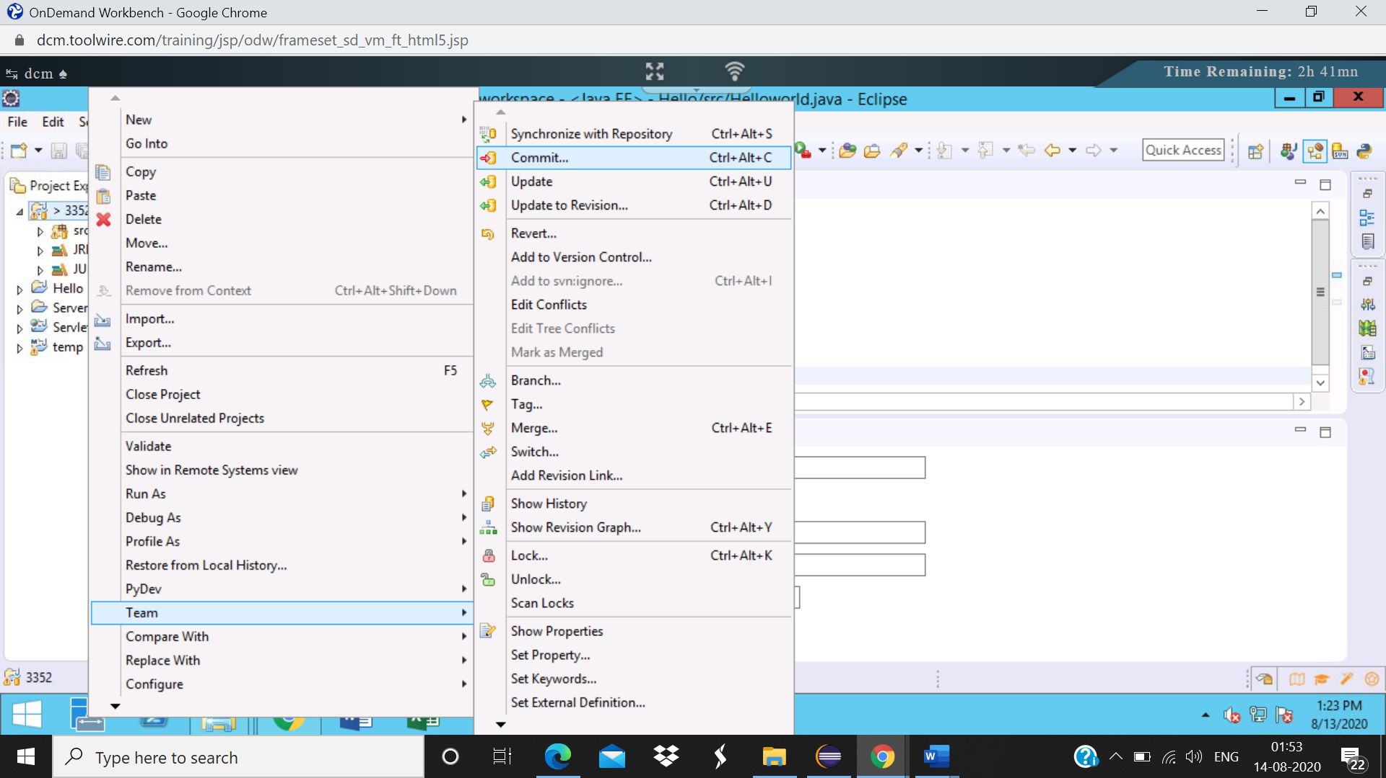

Commit dialog box

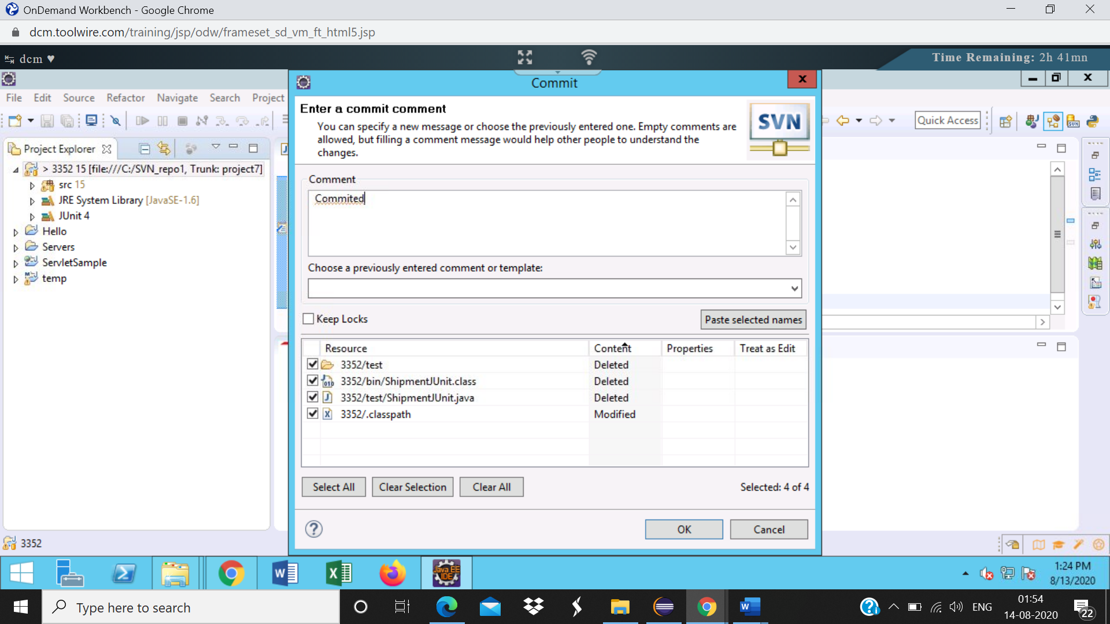

Step14: Verify the files, enter the commit message and click ok



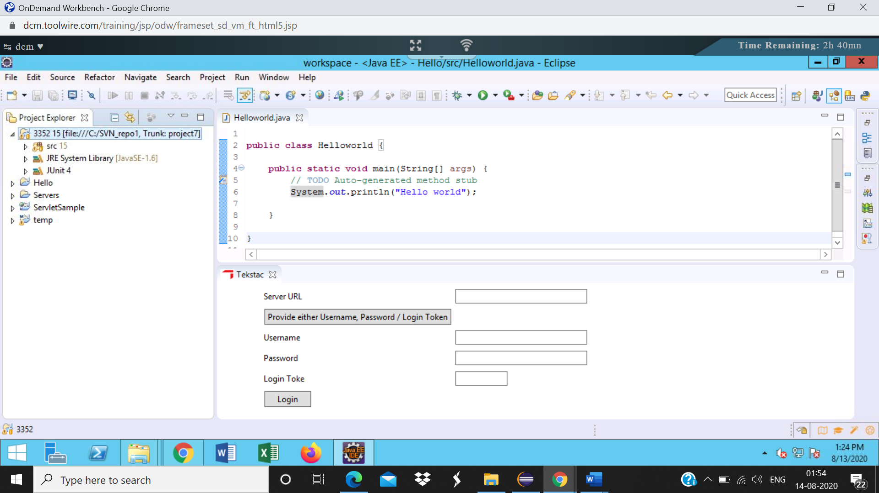

History from svn repo

